Dustin Qualley

November 19, 2019

Foundations of Programming: Python

Assignment07

**Python Script on Binary Files and Structured Error Handling**

**Introduction**

In this document I will illustrate the use using binary files as a method of storing data as well as introduce structured error handling, where the program looks for errors from user input and displays custom error messages.

**The Use of Binary Files**

Binary files are an alternative to text files in the Python programming language. While text files offer convenience because they are editable in a text editor, they are limited to storing a series a characters. Using binary files (.dat) allows the program to store more complex data in a file with a single line of code.

**Pickling**

Python offers functionality known as pickling, where an object structure can be serialized and de-serialized, allowing the data to be saved on a disc. Pickling converts a python object into a character stream.

To pickle code, you first must import the pickle library using the code “import pickle”. You can store the list object in a file using the “dump” command or display the data using the “load” command as shown in ***Figure 1***.

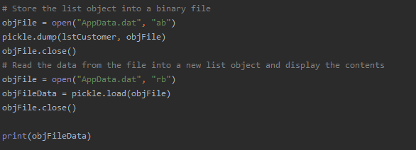

***Figure 1***

**Structured Error Handling**

Structured error handling is a method of handling errors so that the user receives customized error messages back rather than using the python-based error message. There are a variety of ways to apply structured error handling, but in this program I focused on using a Try Statement with a Except clauses.

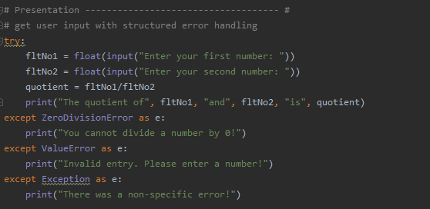

***Figure 2***

In figure 2, the program gets user input and checks the input against specific exception types in the Python language. For instance, “ZeroDivisionError” is a specific exception type that arises if the program attempts to divide a number by zero. “ValueError” is raised when a built-in operation or function receives an argument that has the right type but an inappropriate value. Finally, the code checks to see if *any* exception is raised and alerts the user a non-specific error occurred.

**Summary**

This program illustrates the use of binary files and structured error handling in the Python language.